Name: Irirna Ribarova
E-mail: ribarova.irina@gmail.com
Institution: University of Architecture, Civil Engineering and Geodesy (UACEG) – Sofia, Bulgaria
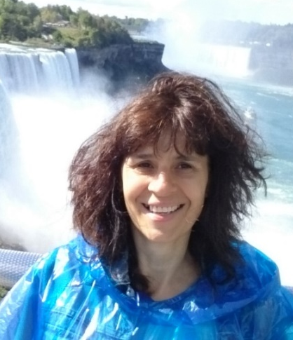 | Irirna Ribarova, PhD, full professor at UACEG. Over 20 years of professional experience in university teaching, research and consultancy in water sector. Numerous EU funded projects (a research and/or project manager) for removal hazardous compounds from wastewaters and sludge; biological processes modeling (in waste water treatment plants (WWTPs) and rivers); water saving technologies; flood and drought management; nutrients (N and P) removal and recovery in WWTP; eco-efficiency of urban water systems; circular economy. Assignments as a consultant from SHER, PM, Aecom, Ramboll, Grontmij and the World Bank for the development of methodologies for avoiding excessive costs for sanitation, assessment of sludge management at national level, the development of a climate change adaptation strategy of Bulgaria, preparation of river basin management plans and flood risk management plans. Experience as European Commission Expert evaluating and monitoring of projects. Practicing engineer - new or upgrade of existing municipal WWTPs; and preparation of feasibility studies.
References (max. 5 relevant references)
1. Stanchev, P., Ribarova, I., 2016. Complexity, assumptions and solutions for eco-efficiency assessment of urban water systems, Journal of cleaner production, 138, 229-236
2. Ribarova, I., Dimitrova, S., Lambeva, R., Wintgens, T., Stemann, J., Remmen, K., 2017. Phosphorus recovery potential in Sofia WWTP in view of the national sludge management strategy, Resources, Conservation and Recycling, 116, 152-159
3. Dimova, G., Tzanov, E., Ninov, Pl., Ribarova, I., Kossida, M., 2013. Complementary Use of the WEAP Model to Underpin the Development of SEEAW Physical Water Use and Supply Tables, Procedia engineering, 70 (2014), 563-572
4. Daniell, K., Máñez, M., Ferrand., N., Kingsborough, A., Coad, P., Ribarova, I. 2011. Aiding multi-level decision-making processes for climate change mitigation and adaptation, J of Regional Environmental Change, Vol.11, No.2, pp. 243-258.
5. Ribarova, I., Assimacopoulos, D., Jeffrey, P., Daniell, K., Inman, D., Vamvakeridou-Lyroudia, L., Melin, T., Kalinkov, P., Ferrand, N., Tarnaki, K., 2011. Research-supported participatory planning for water stress mitigation. J. of Env. Planning and Management, vol. 54, issue 2, p.283-300.
This project has been funded with support from the European Commission. This publication reflects the views only of the author, and the Commission cannot be held responsible for any use which may be made of the information contained therein.

